**Prerequisites**

* Azure DevOps & Azure account for Azure Cloud (Lab 2)
* Lab 2.1
* Create an empty repo in your Github
* Download <https://github.com/femilv/femicoreapp.git>
* Unzip the femicoreapp downloaded repo and copy PartsUnlimited folder to your cloned empty repo.

**Deploying a .Net application to Azure**

**What’s covered in this lab**

* Create a new Azure App Service and configure the web app to use .NET
* Use Azure App Service Task to deploy

## **Creating Azure Web App**

1. Launch the [Azure Cloud Shell](https://docs.microsoft.com/en-in/azure/cloud-shell/overview) from the portal. To deploy to a resource group, enter the following command

az group create --name MyResourceGroup --location eastus

1. To create an App service plan

az appservice plan create --resource-group MyResourceGroup --name MyPlan --sku S1

1. Create the web app with a unique app name

az webapp create --resource-group MyResourceGroup --plan MyPlan --name MyUniqueAppName

## **Updating the App Settings for the Web App**

Next, navigate to the Web app that you have created. As you are deploying a .net application, you need to change the web app’s web container to .NET

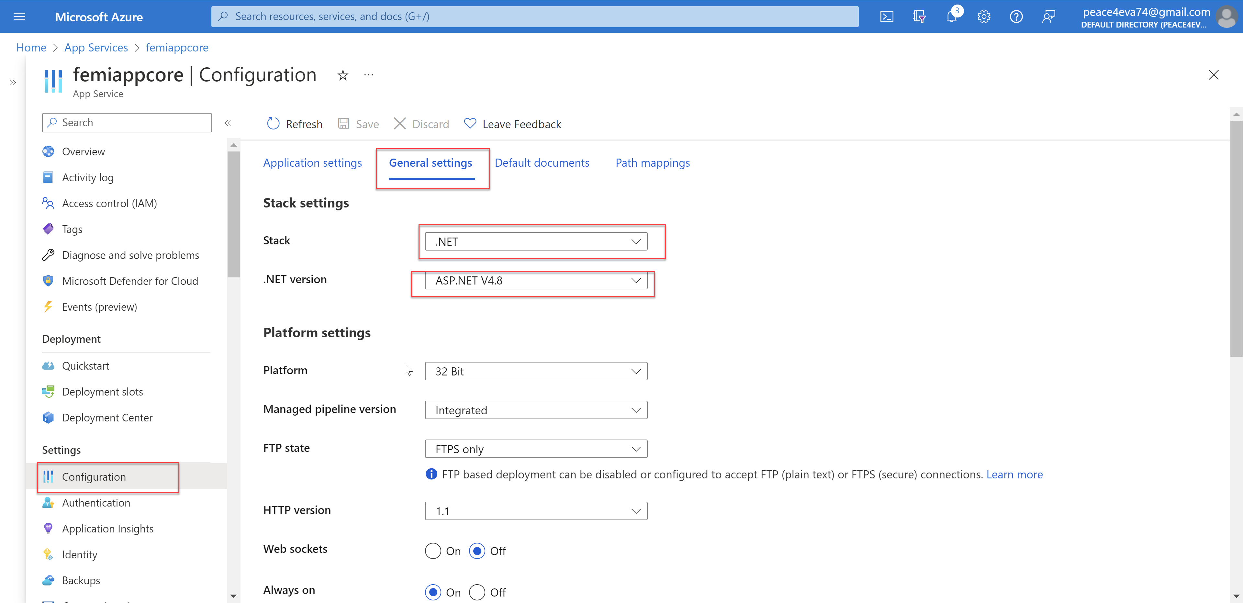

Select **Overview** and click **Browse**.

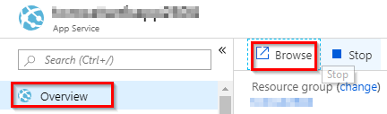

**The web page will look like the below image.**

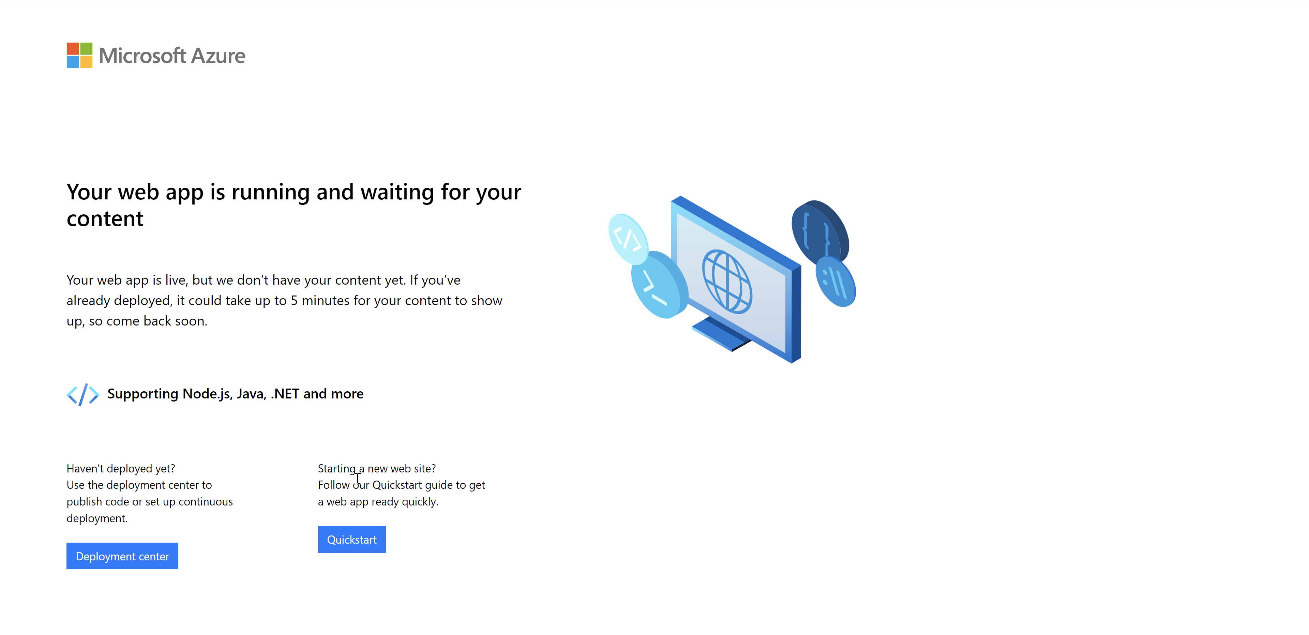

**You have now setup and configured all the resources that is needed to deploy and run the application**.

### How to create Web App in Azure Cloud Portal

WebApp is an App service provide by Azure Cloud for hosting your application. It supports .NET, Java, PHP,  Python and NodeJS. It is a fully managed Platform as a Serice (PaaS) where developers can deploy mobile or web applications in Azure Cloud.

**Steps for Creating WebApp in Azure Portal**  
  
1. Now to login [portal.azure.com](http://portal.azure.com/)  
2. Click on App services

[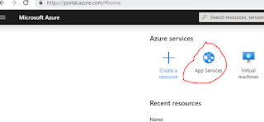](https://1.bp.blogspot.com/-HqnjtpKckYU/XkRaS0i4XxI/AAAAAAAABX4/KGqjyA3j6k8zo31YS0GNL5PesJieCexUACLcBGAsYHQ/s1600/appservice.PNG)

3.Click on + Add or click on Create app service

[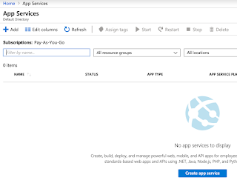](https://1.bp.blogspot.com/-ASQLDExMaIw/XY_FL9yRNnI/AAAAAAAABPA/veqruuoyzzcg3tcgv-vq-pH22v2vFWLUACLcBGAsYHQ/s1600/Screen%2BShot%2B2019-09-28%2Bat%2B3.38.31%2BPM.png)

Click on Web App.

[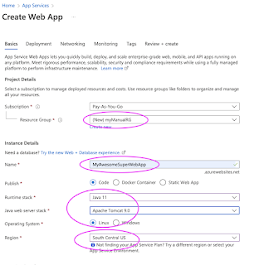](https://blogger.googleusercontent.com/img/b/R29vZ2xl/AVvXsEicQp6NIVeBQPqqz1Ul9wGm5-nVooOPIhSfRHKNno7UTKN3mlFd80ujyIr2FOXsQyecX24KLZcFJCjXqQwP-LOwx4frmWG49FkonnXb2z7SUyG5xOWmjyul8ow12AbsX-uknTbgaBK3ZrADYt_H_G3xtUvLNPg6gIkAv17L8oZBlmrvRnC-WcwYMKqe/s782/Screen%20Shot%202022-07-16%20at%204.22.04%20PM.png)

Choose your Azure subscription  
  
Create a new resource group(for first time if you create an app service, otherwise you can use existing group name)  
Enter App service name(it should be unique)  
**Publish** as Code  
**Run time stack** xxxx  
**Operating System** as xxxx  
**Region** as what ever you are close to.  
Enter name  
Choose SKU and size as given below:

[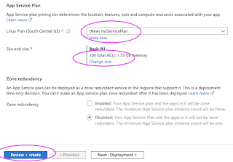](https://blogger.googleusercontent.com/img/b/R29vZ2xl/AVvXsEhhhxrh9OWWbRNqtU0tUVIrbR-i44cxr1VwVD4vEgeqDVTm9dFyiigmgsi1f-AWK_Q7nnZGD90EUAYFNibPkgMTWbx1GrFSEf5k4Uycq1BfV4kvLOJcc-9fQmVjQNXvwFAwIJrG_ER5_Lz1RHujBwbdp7gKjpndfzHvbYcX_mm-8M_0fnhbvveuOU9p/s728/Screen%20Shot%202022-07-16%20at%204.23.39%20PM.png)

[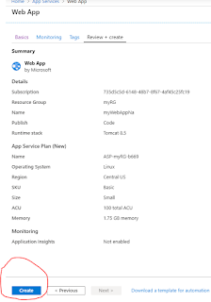](https://1.bp.blogspot.com/-uHPJn3W-k-E/XkRb6WFDqUI/AAAAAAAABYM/khxjkzQEqKsMMOy4ZKPCMVi3fvRT6HPtQCLcBGAsYHQ/s1600/webapp2.PNG)

Click on Apply  
Now click on Apply & Create.  
This will take bit time to create the app service. Once WebApp is created, go to resources, click on Webapp name and click on the URL.

### Migrate WebApp from GitHub to Azure Cloud - Build and Release Pipelines in Azure DevOps to migrate WebApp from GitHub to Azure Cloud

We are going to migrate application from GitHub to Azure Cloud using Azure Pipelines offered from Azure DevOps.

Building pipelines in Azure DevOps is really easy, you can migrate your web application code from any where into Azure Cloud by using Azure pipelines.

[[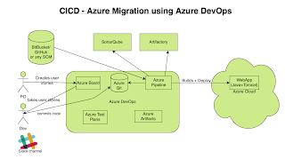](https://1.bp.blogspot.com/-cHH4rB6jNJI/X3dWlmX_iDI/AAAAAAAADEk/cBzg6W0skREKEGtw87f8exwfKHamwiU1ACLcBGAsYHQ/s1662/Azure%2BCICD%2BV4.png)](https://1.bp.blogspot.com/-cHH4rB6jNJI/X3dWlmX_iDI/AAAAAAAADEk/cBzg6W0skREKEGtw87f8exwfKHamwiU1ACLcBGAsYHQ/s1662/Azure%2BCICD%2BV4.png)

**Pre-requistes:**

(If you already have a WebApp setup in Azure cloud, move to next step)

You need to create WebApp in Azure Cloud. WebApp is an App service (mostly Platform as a Service) provide by Azure Cloud to migrate any web applications.  
  
  
**Creating Azure pipelines in Azure DevOps**  
  
1. Now go to your visual studio project page --> <https://dev.azure.com/>  
Select the Project dashboard you already created.  
  
Click on Pipelines, Builds.

[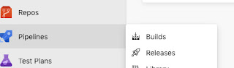](https://4.bp.blogspot.com/-DvfxR9Q6oCM/XGIw09RdtHI/AAAAAAAAAyk/aBfsL7G-c5gVwtvuQ0ZNbZRxqOd9G9V1QCLcBGAs/s1600/WhatsApp%2BImage%2B2019-02-11%2Bat%2B8.26.26%2BPM.jpeg)

2. Click on New pipeline and click on use the classic editor to create a pipeline without YAML

[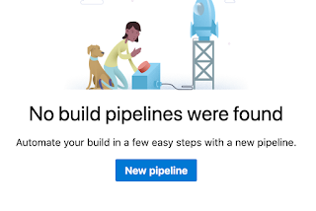](https://4.bp.blogspot.com/-9nmywwGJeHk/XGIxE4zmKLI/AAAAAAAAAys/GcdI-UiQ_hkNie9YP2CQXisQyEMBEwowACLcBGAs/s1600/Screen%2BShot%2B2019-02-11%2Bat%2B8.27.14%2BPM.png)

[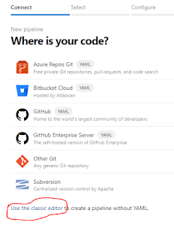](https://1.bp.blogspot.com/-FQ6Xk8xwsx0/XkReeE__7AI/AAAAAAAABYw/G7_uiNrc4v0Eq0UxH6v431mKZVMrKXOvQCLcBGAsYHQ/s1600/classic%2Beditor.PNG)

3. Select source repository as GitHub and click Authorize using OAuth

[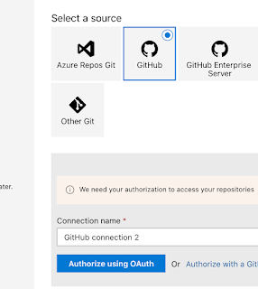](https://1.bp.blogspot.com/-ZmowwBBY-uA/XnvbOjmsGrI/AAAAAAAABl0/S3IsTcU39rYjwLST7HWkTZJ70u5I5U-cgCLcBGAsYHQ/s1600/github-oauth.png)

4. Now click on Authorize Azure Pipelines, enter GitHub password if it asks.

[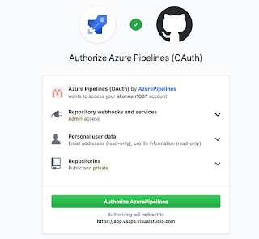](https://1.bp.blogspot.com/-uKZCyZLgarE/XnvbZSElH2I/AAAAAAAABl4/dJ5_4uTWwRU-hKyeKoeK6PmOCGVq0FFLgCLcBGAsYHQ/s1600/github-vsts.png)

5. Now you should be able to select repositories by clicking ... dots

[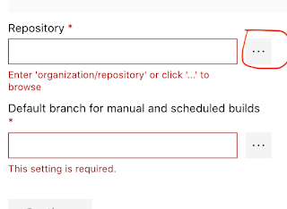](https://1.bp.blogspot.com/-PVpQvIaJ9_w/Xnvb65G0rOI/AAAAAAAABmE/-TVGvByKk7EACF_s_G7qfT6D9gVpxXNWgCLcBGAsYHQ/s1600/three%2Bdots.png)

Click  **Save** & **Queue** to trigger the build and wait for the build to complete.

 Since our application is ASP.Net core, type core and Choose ASP.Net Core

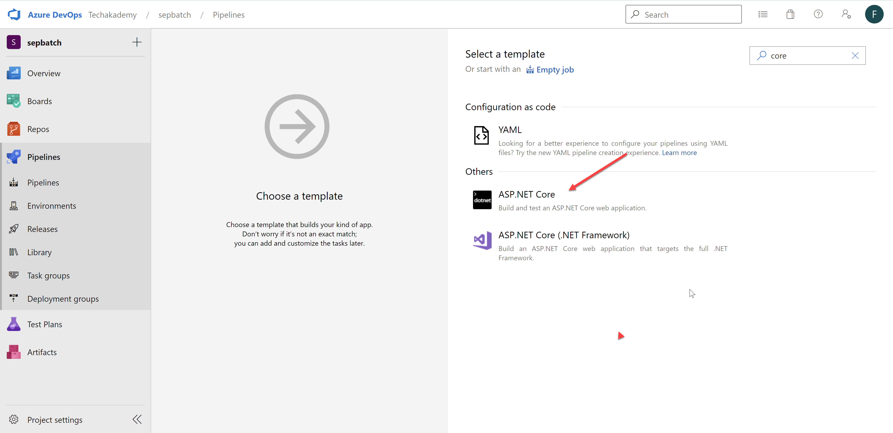

Click on pipeline name and re-name per your naming standard

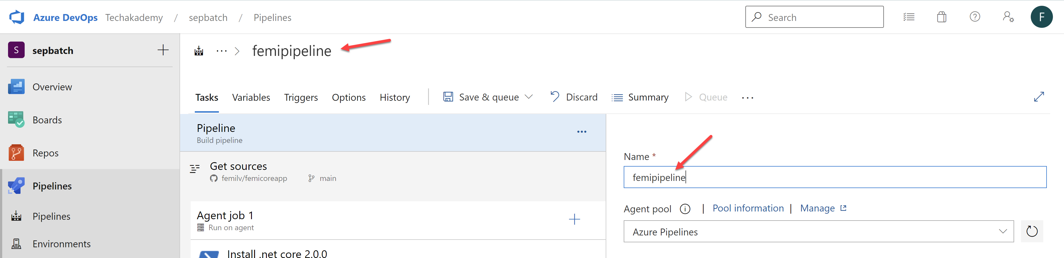

Add Use .NET Core sdk 2.1.x

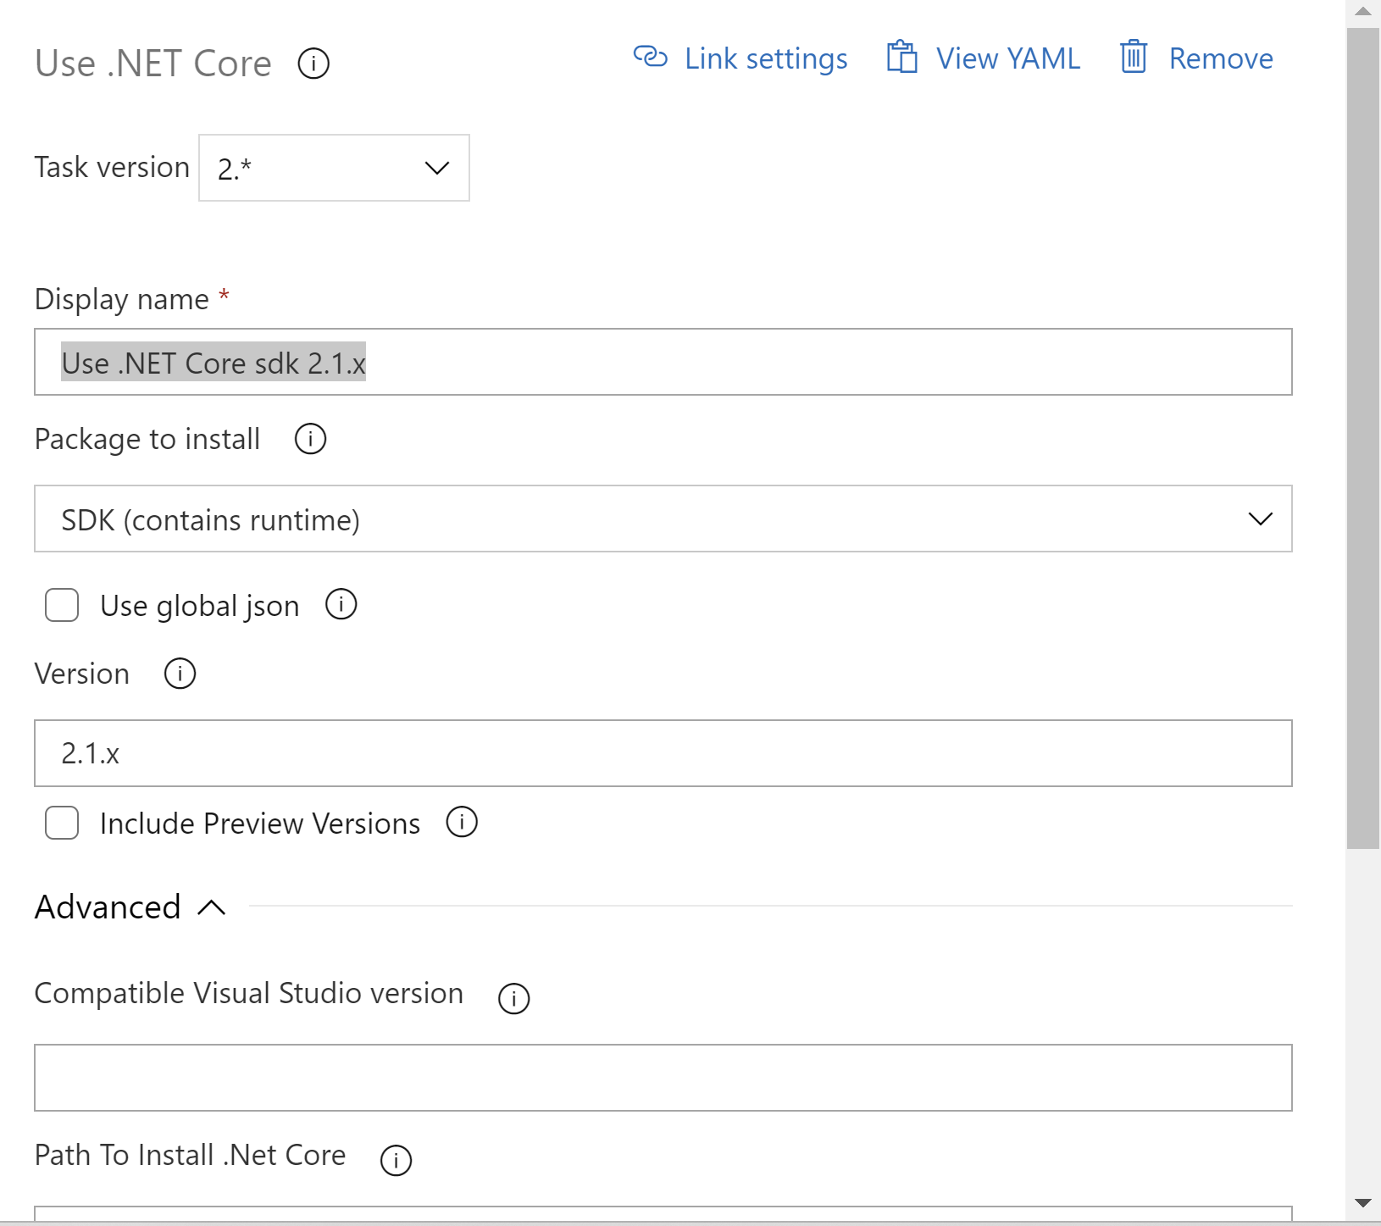

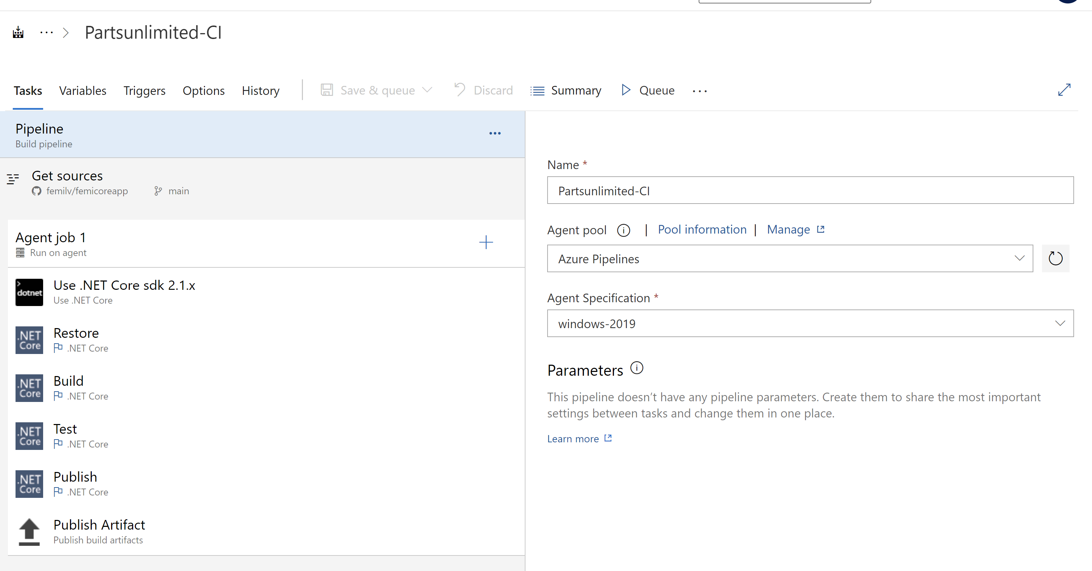

Modify Restore and Build task, use below paths:

src/PartsUnlimitedWebsite/PartsUnlimitedWebsite.csproj

src/PartsUnlimited.Models/PartsUnlimited.Models.csprojtest/PartsUnlimited.UnitTests/PartsUnlimited.UnitTests.csproj

Click  **Save** & **Queue** to trigger the build and wait for the build to complete.

Once the build succeeds, select **Releases** under **Pipelines**.

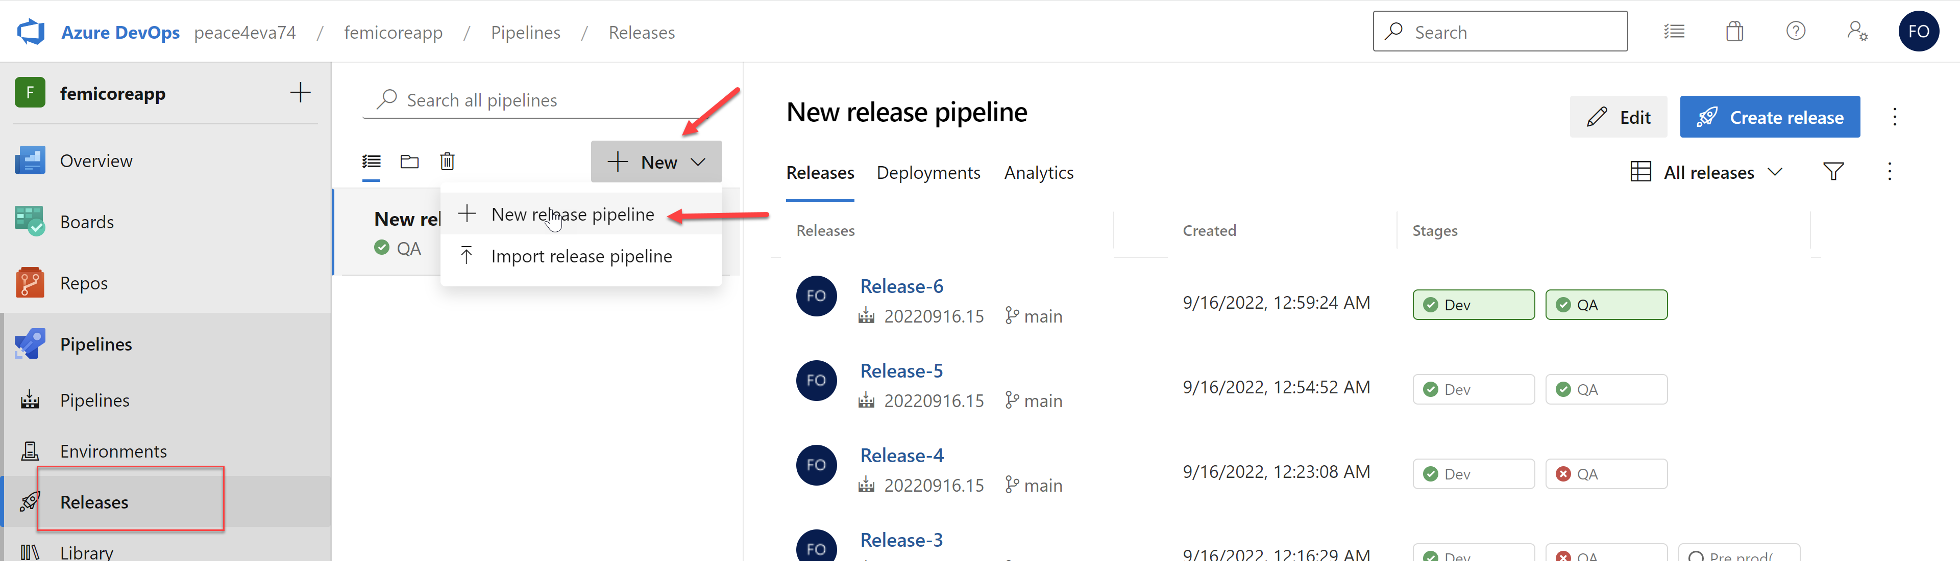

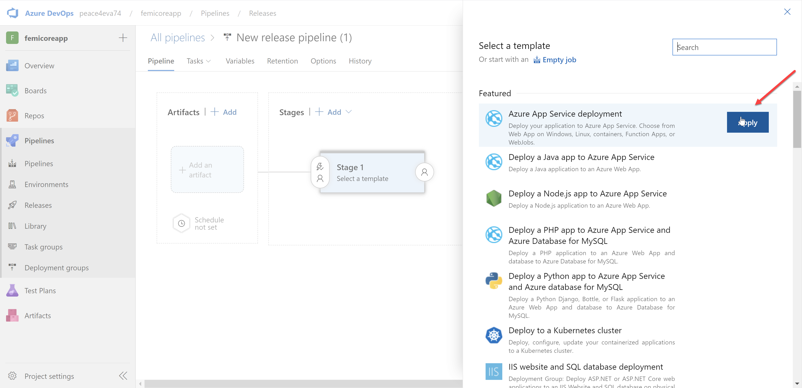

Select the **Deploy Azure App Service** task, choose the **Azure subscription** details and select **App Service name** from the dropdown.

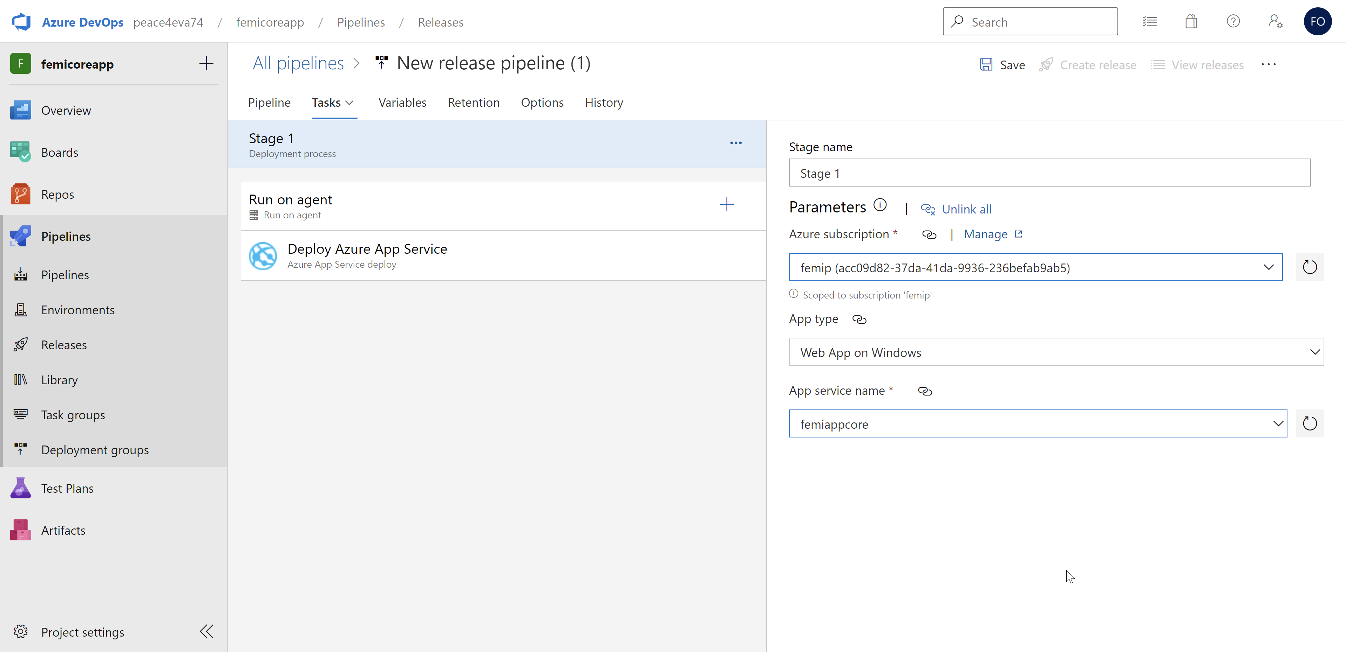

Click on **Save**

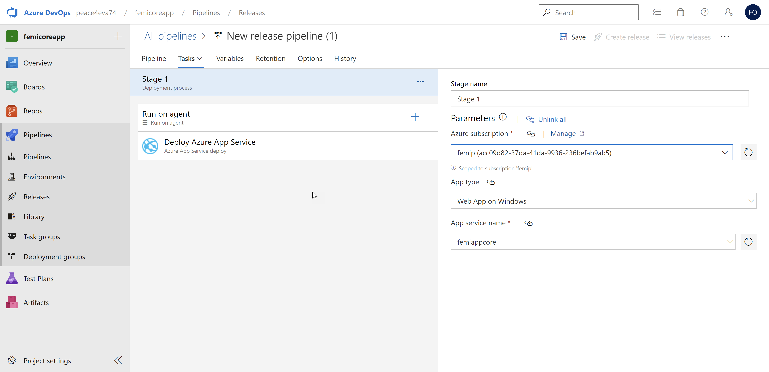

and then **Create Release** to start a new release

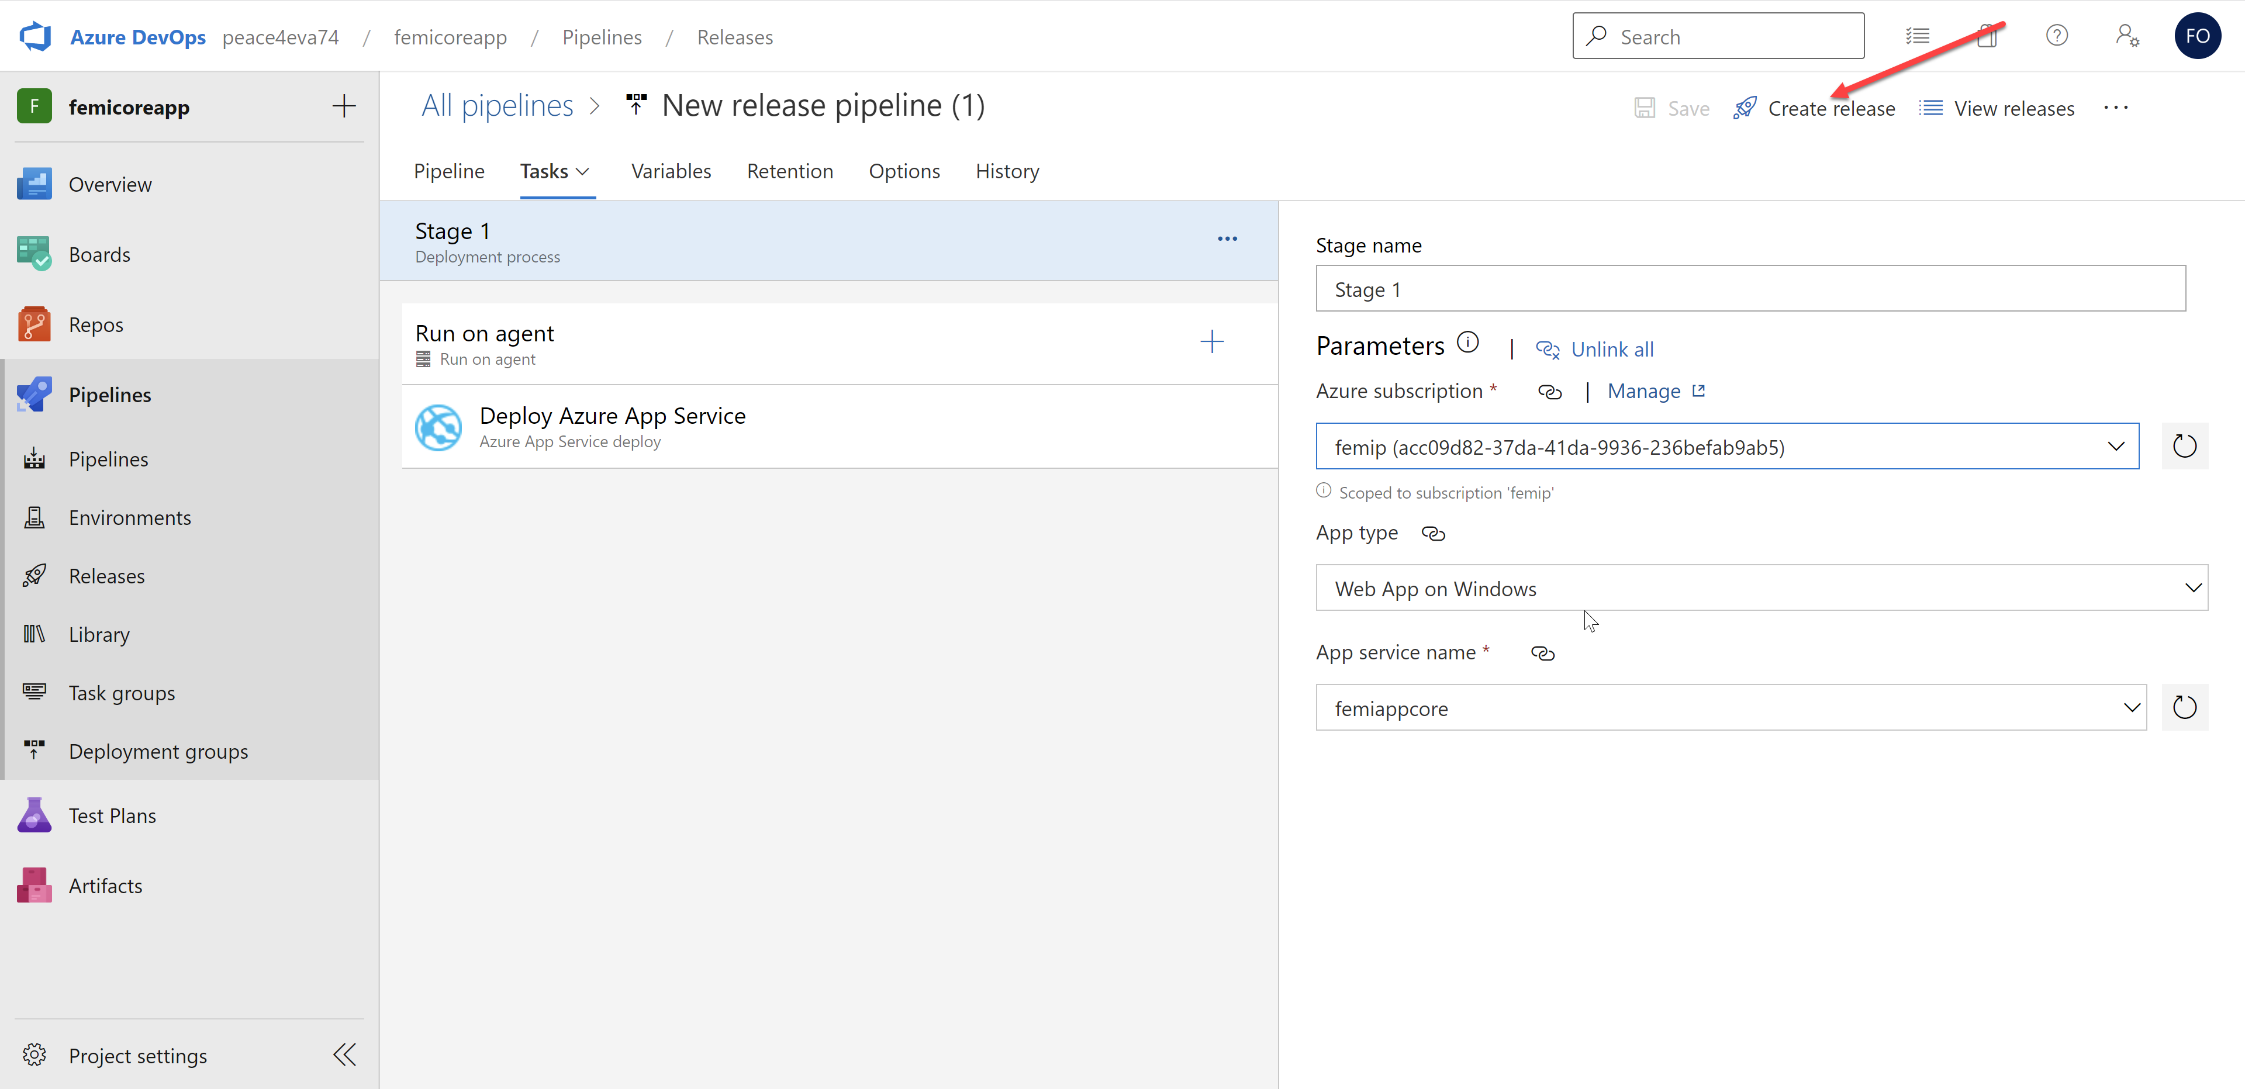

Make sure the artifact is pointing to the **Build** artifact as shown below.

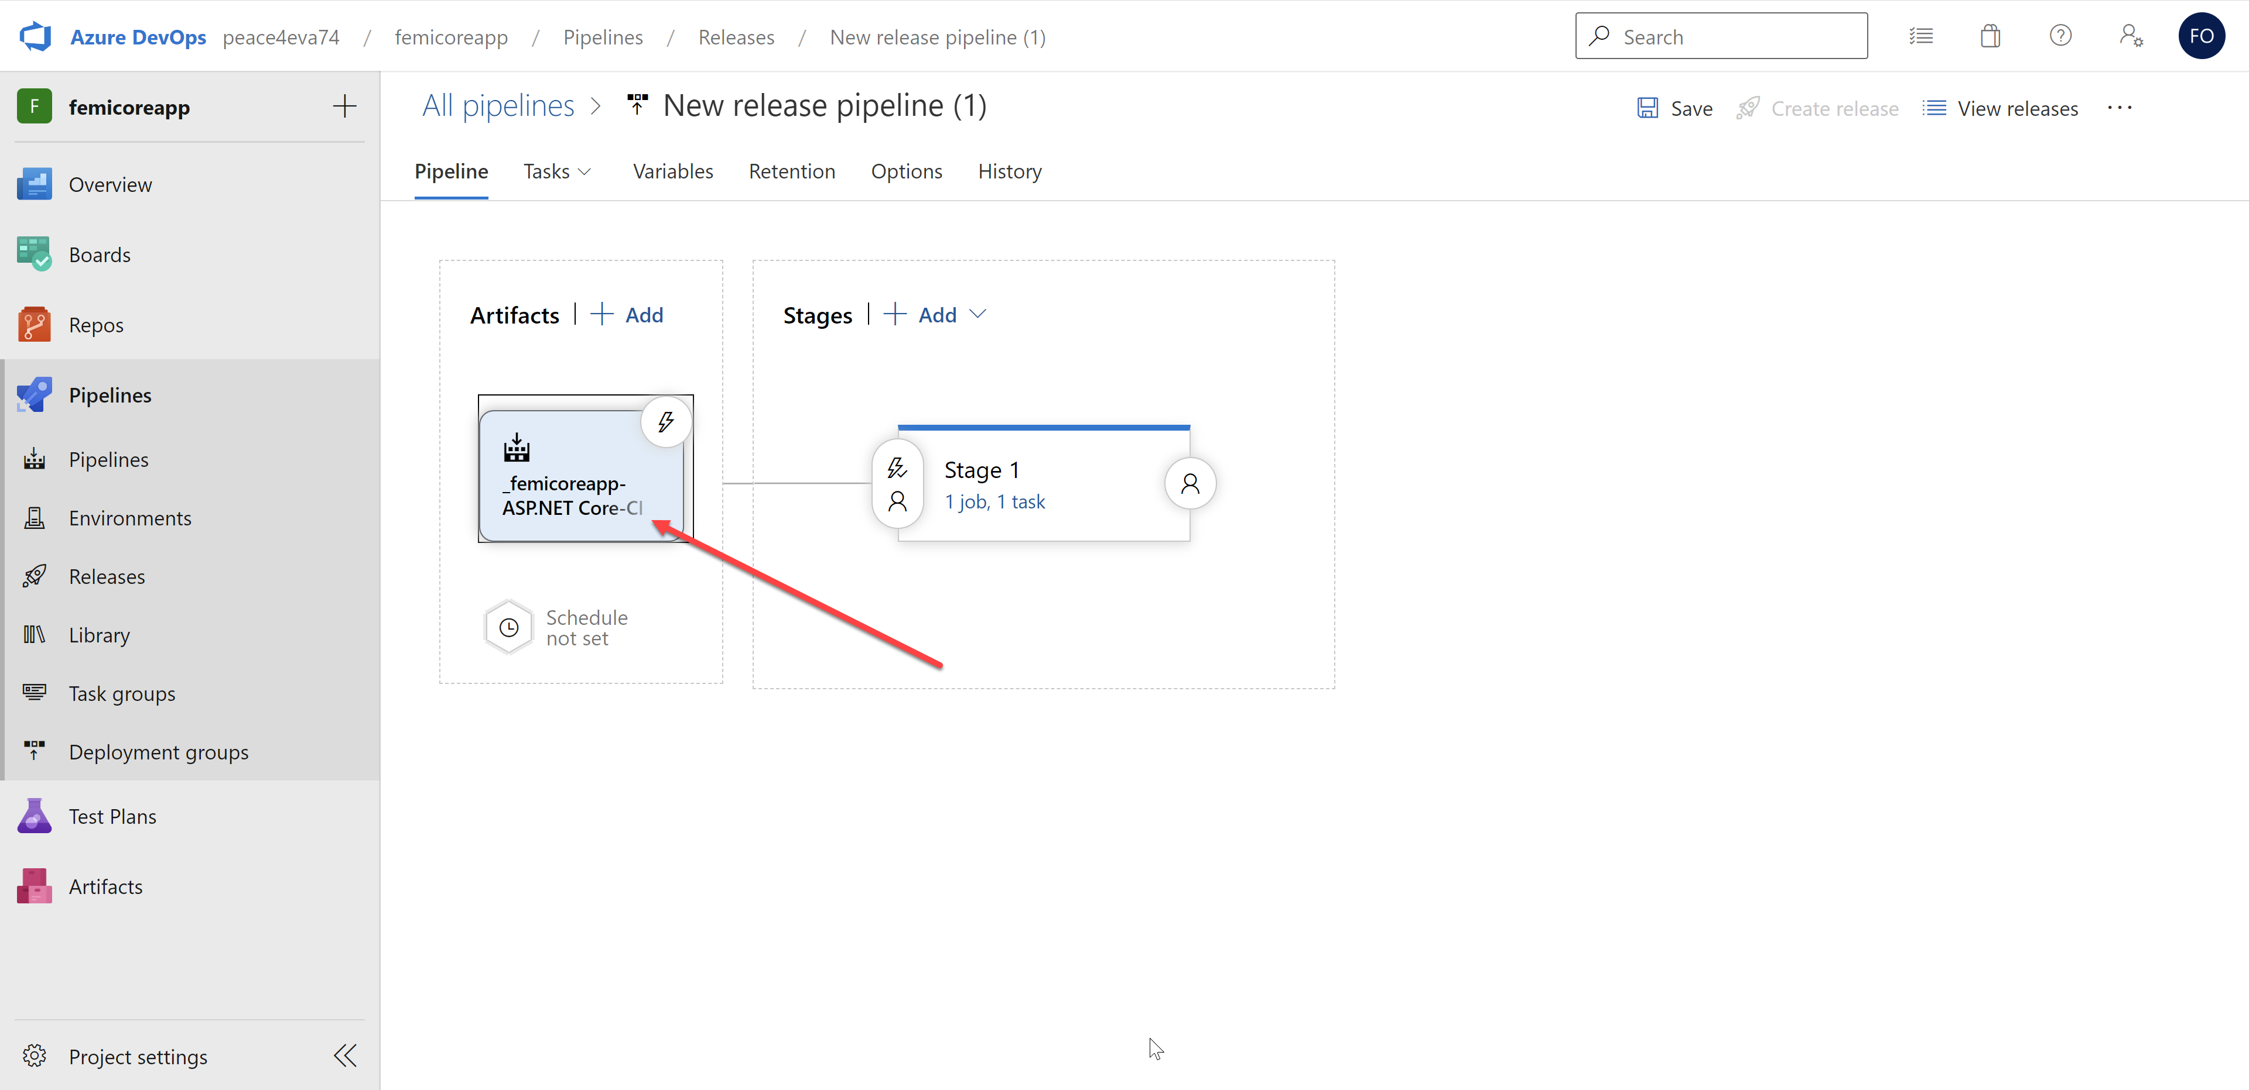

Wait for the release to complete. Then navigate to the Web App and select the **URL** from the overview blade .

Your home page should look like the image below.

